What: How to strip span formatting in Compliance Assist: Accreditation narratives
Why: Sometimes users fail to paste as plain text when copying data from external sources. This can cause inconsistent font, font sizes, and font colors
Who on Campus: Users with ‘Contributor’ access to the narrative
Who at Campus Labs can help resolve this: Support Team (support@campuslabs.com)
Where is this located: Accreditation Options Dashboard View Appropriate Requirement
How to Strip Span Formatting: (In the Edit Mode of your narrative)
- Highlight the text
- Select paintbrush icon
- Select Strip Span Elements

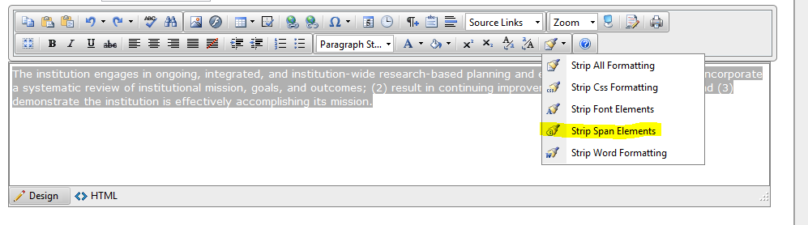
The system will strip the unwanted html characters.
- Hit Update to save the changes
**Note you must only highlight text that does not include tables to use this function.

